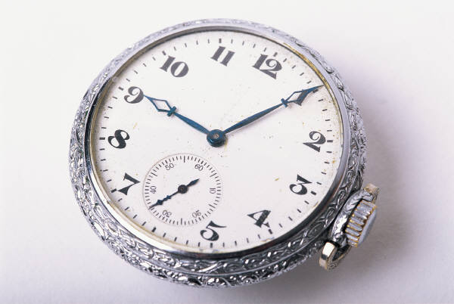

Watch

represents the fact that I have time to spend with family and friends when I run my PartyLite business
- no boss to ask for time off!!
- no required work days!!

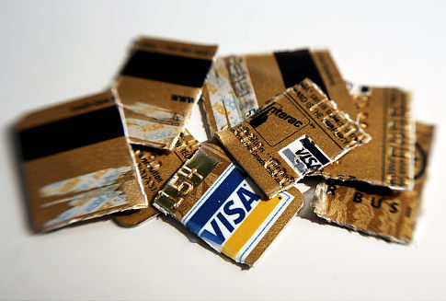

Cut-Up Credit Card

represents the fact that I can pay off credit card debt with the income that I make with PartyLite

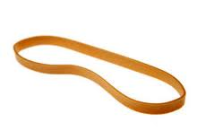

Rubber Band

represents the flexibility I have to manage my PartyLite business the way I want

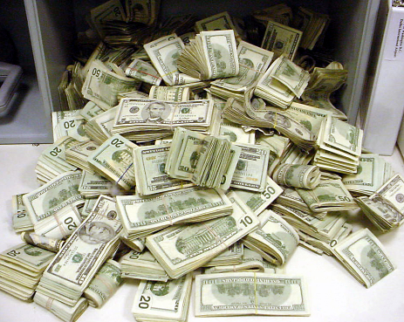

Money

represents the unlimited money I can make with my PartyLite business
- the average consultant makes $35 - $50 per hour
working part time

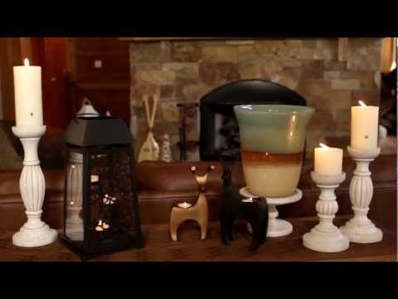

Product

represents the product discounts that I get as a consultant
- 50% off all product
- host specials
- clearance items
- business boosters

Blank Card

represents the amount of money I need to start my PartyLite business
– NONE!!
I GET A FREE KIT JUST FOR GIVING PARTYLITE A TRY!!!

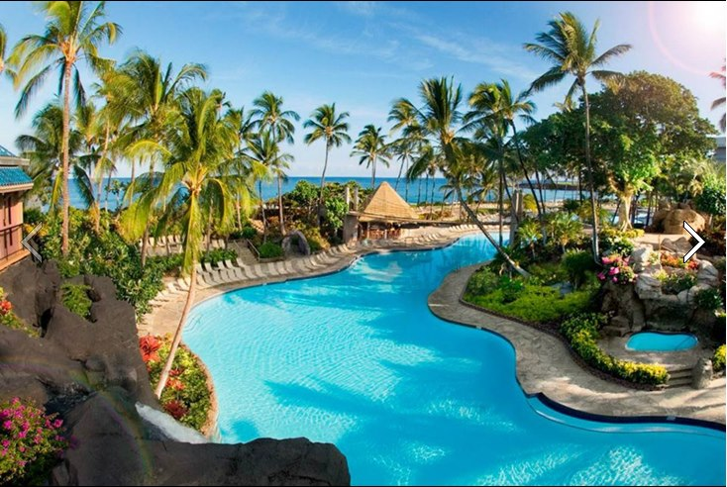

Hawaiian Resort

represents the FREE trips I can earn just for doing my job!
- this year we are going to the big island of Hawaii!!

